Assignment – 6
Basic Search Strategies – 8-Queens Problem

Problem Statement:
The 8-Queens Problem is a classic problem in combinatorial optimization and backtracking algorithms. The objective is to place eight queens on an 8x8 chessboard in such a way that no two queens threaten each other. This means that no two queens can be placed in the same row, the same column, or along the same diagonal.

Software used:
- Python 3.x
- Google Colab

Libraries and packages used:
- NumPy: For representing the chessboard.
- Matplotlib: For visualizing the chessboard and the solution.

Theory:
The 8-Queens Problem can be approached using various search strategies, primarily:
- Backtracking: This is a depth-first search approach that incrementally builds candidates to the solutions and abandons a candidate as soon as it is determined that it cannot lead to a valid solution.
- Constraint Satisfaction: The problem can also be viewed as a constraint satisfaction problem, where each queen's placement must satisfy constraints regarding rows, columns, and diagonals.
The constraints can be summarized as:
- Only one queen per row.
- Only one queen per column.
- Only one queen per diagonal.

Methodology:
- Define the Board: Represent the 8x8 chessboard as a 2D array, list, or any other suitable data structure. Each cell can be empty or can contain a queen.
- Implement a Backtracking Algorithm:
- Start placing queens one row at a time.
- For each row, try placing a queen in every column.
- Check if placing the queen does not lead to any conflicts with already placed queens.
- If a placement is valid, recursively attempt to place queens in the next row.
- If placing a queen leads to a solution, record the configuration; if not, backtrack by removing the queen and trying the next column.
- Termination Conditions:
- If all eight queens are placed successfully, print or store the board configuration.
- If all columns are tried and no valid placements are found, return to the previous row (backtrack).

Advantages:
- Simplicity: The backtracking approach is easy to understand and implement.
- Flexibility: It can be easily adapted to find all solutions or the first solution.
- Efficiency: While backtracking can be inefficient for large problems, it performs well for the 8-Queens Problem due to the small size of the board.

Limitations:
- Computational Complexity: In the worst case, the time complexity can be exponential O(N!), where N is the size of the board. However, due to the pruning nature of backtracking, the average case is much better.
- Memory Usage: Storing all configurations may consume considerable memory if solutions are not being discarded quickly.

Applications with example:
- Artificial Intelligence: The 8-Queens Problem is a common problem in AI used to teach basic search algorithms and constraint satisfaction.
- Optimization Problems: The techniques used to solve the 8-Queens Problem can be applied to other optimization problems where constraints must be satisfied.

Working / Algorithm:
- Initialize the Board: Create an 8x8 array (or list) initialized with zeros, where 0 represents an empty cell and 1 represents a cell with a queen.
- Define the Backtracking Function: Create a recursive function to attempt placing queens
- Print the Board Configuration: Create a function to print the current configuration of the board.
- Execute the Algorithm: In the main function, initialize the board and start the solving process

Diagram:
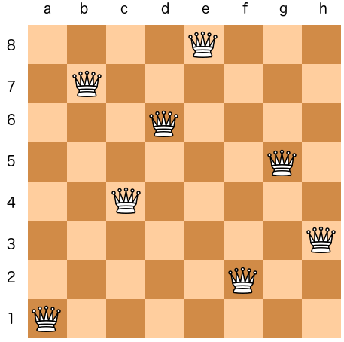

Conclusion:
The 8-Queens Problem serves as an excellent example of basic search strategies and backtracking algorithms in computer science. The backtracking approach efficiently explores potential solutions while ensuring no two queens threaten each other. This assignment illustrates the power of recursion and constraint satisfaction in solving combinatorial problems, laying the groundwork for more complex algorithms and optimization techniques.

